Group #1: Eliza Doles, Ryan Foerst, Raphael Doelker & Brayan Conde

Professor Moutrane

BUS 2000 REC

14 December 2024

# Market Research: The Walt Disney Company

## **History & Overview**

The Walt Disney Company is a global family media and entertainment conglomerate. Founded in Los Angeles, California, on December 16th, 1923, by brothers Walt Disney and Roy O. Disney as the Disney Brother’s Cartoon Studios. The company quickly evolved from a small animation studio to one of the most iconic and influential multi-billion-dollar global enterprises in modern history. Ever since the creation of their first character, Steamboat Willie (which would eventually evolve into their iconic character Mickey Mouse) in 1928- to the release of the first feature-length color animation film in 1938 “Snow White and the Seven Dwarves”- Disney has been changing the landscape of studio and animated film for the last century, and has become synonymous with family-friendly entertainment, producing beloved films, characters, and experiences that resonate with audiences across generations. Headquartered in Burbank, California, Disney operates on a global scale, not only with their studio entertainment but with their immersive and interactive theme parks and cruise lines- with key locations including Anaheim, California (Disneyland Resort); Orlando, Florida (Walt Disney World Resort); Paris, France (Disneyland Paris); Shanghai, China (Shanghai Disney Resort), and Tokyo, Japan (Tokyo Disneyland). To operate these parks and studio entertainment facilities, the company employs more than 233,000 people, with “74% of this workforce residing in the United States and the remaining share working internationally” (Statista). Their current CEO is Bob Iger. Under Iger, Disney has become even more of a significant player in the entertainment and media industries, with a current market capitalization of around $205.25 Billion (Yahoo Finance). This high market cap is primarily due to its previous acquisitions of Capital Cities/ABC Studios/ ESPN, Pixar Animation Studios, Marvel Comics, Lucasfilm Ltd., 21st Century Fox Productions, and Hulu (a former streaming service competitor). Acquisitions of these companies have helped catapult Disney’s overall income and pull in the media industry. Due to Disney’s global success, they have achieved accolades from prominent business and media rankings. The Walt Disney Company currently holds the position as the “#1 Sector Leader: Media” (Fortune) based on revenue, according to Fortune magazine and “#12 in the Most Admired Companies in the World” (Fortune). They also rank “#48 in the United States Fortune 500” (Fortune) and “#131 in the Fortune Global 500” (Fortune) which is considered a mark of prestige and signifies a high level of financial success and market influence. Additionally, Forbes magazine rated the company as “#7 in World’s Most Valuable Brands” (Forbes).

This essay seeks to highlight The Walt Disney Company’s position as an unparalleled force in global entertainment. This essay will look at Disney as a whole including their mission statement and goals, business categories/markets/ and products, competitors, ESG, financials and current events.

## **Mission Statement and Goals**

“The mission of The Walt Disney Company is to entertain, inform and inspire people around the globe through the power of unparalleled storytelling, reflecting the iconic brands, creative minds and innovative technologies that make ours the world’s premier entertainment company” (Disney). As the world’s premier entertainment company, Disney strives to achieve several objectives that align with its mission. Central to its goals is delivering compelling stories and characters that resonate with audiences of all ages, leveraging its vast portfolio, including Pixar, Marvel, Lucasfilm, and 20th Century Studios. The company is also focused on expanding its digital and streaming platforms, such as Disney+, Hulu, and ESPN+, to make its content more accessible globally. Enhancing guest experiences. Disney is committed to promoting diversity and inclusion by creating stories that reflect a wide range of cultures and perspectives, while fostering representation and an inclusive workplace culture. Additionally, Disney seeks to expand its global presence by adapting content to local markets and strengthening partnerships worldwide. By embracing innovation and blending tradition with forward-thinking strategies, Disney aims to maintain its position as a cultural icon and leader in the entertainment industry.

## **Business Categories, Markets and Products**

Disney is a global leader in the entertainment and media industry, operating across several key business segments that cater to diverse audiences and markets. Its Media Networks division includes television networks such as ABC, ESPN, Disney Channel, and National Geographic, which provide a mix of news, sports, and family-friendly programming. This segment plays a big role in capturing the attention of cable and streaming audiences, appealing to a wide range of demographics, from sports enthusiasts to families seeking educational, high-quality content. The Parks, Experiences, and Products segment is one of Disney’s most iconic segments, due to its theme parks, resorts, and cruise lines. These attractions are designed to immerse guests in the magic of Disney, drawing millions of tourists and families from around the globe annually. This segment also includes consumer products like toys, apparel, and collectibles, allowing fans to connect with Disney’s beloved characters and stories in their daily lives. Disney’s Studio Entertainment division is the backbone of its creative output, producing and distributing films, television series, and music through celebrated brands such as Walt Disney Studios, Pixar, Marvel Studios, Lucasfilm, and 20th Century Studios. This segment creates amazing franchises and storytelling that resonate with people of all ages, making Disney a dominant force in global box office revenues and pop culture. Complementing these offerings, the Streaming segment focuses on delivering Disney content directly to audiences through its platforms, including Disney+, Hulu, and ESPN+. These platforms have become central to Disney’s strategy in the digital era, providing families and younger consumers with convenient access to a library of entertainment that spans animated classics, live-action films, sports programming, and original series.

## **Competitors**

Disney works in one of the most competitive industries globally, with competitors like Warner Bros Discovery and Netflix. According to Yahoo Finance, $91 billion was reported for Disney in terms of revenue for 2024. Disney remains one of the leading competitors, surpassing Netflix’s $37 billion in revenue (Yahoo Finance). Disney's diverse portfolio gives it a significant advantage, with their streaming service, merchandise, parks and film releases they are able to create consistent revenue streams. Disney's direct to consumer offerings, including Disney+, Hulu and ESPN+, has made it a strong competitor to Netflix. While Netflix remains the leader in streaming with a large subscriber base, Disney's content library continues to grow, making it a potential rival in the coming future. For instance, Disney+ focuses on family friendly and franchise content, such as Marvel Entertainment, Star Wars, and Pixar, which have a broad-based appeal. Additionally, their ability to create films that rank among top earners each year gives it a major upper hand over other competitors. Films like *Inside Out* 2 and *Deadpool & Wolverine* have grossed over a billion each, with *Moana 2* following up behind, showing how Disney is able to position themselves as a leader in the entertainment space (Whitten).

From an investment viewpoint, Disney's 29% stock increase over the past year outperformed Netflix's 18% growth, and with their PE ratio being 41.67 it showcases stronger investor confidence in long term growth (Yahoo Finance). However, Disney still faces many challenges in scaling its streaming platform profitability due to high content costs. Regardless of this, the company’s diversified approach and international growth strategies keep it ahead of its competitors in terms of overall financial performance. Over the past few years, Disney's revenue has grown from $67 billion to $91 billion in 2024, demonstrating a 35% increase (Yahoo Finance). Also, Disney's stock has gone up by 29% over the past year, showing strong investor confidence despite its competitive pressures. With Disney’s multiple revenue streams, it continues to be a leader in the entertainment industry, with continued growth as it grows its streaming platform and global markets.

## **Environmental Social Governance (ESG)**

Disney’s commitment to Environmental, Social, and Governance (ESG) principles demonstrates the company’s dedication to sustainable growth and corporate responsibility. Over the past decade, Disney has integrated these values into its business practices, establishing a framework that balances profitability with ethical stewardship. By addressing critical issues such as climate change, labor rights, and diversity, Disney aligns its operations with global sustainability goals while maintaining its position as a leader in the entertainment industry. Disney has prioritized reducing its environmental impact, by focusing its efforts on emissions reduction, waste management, and resource conservation. Between 2021 and 2020, the company successfully reduced its greenhouse gas (GHG) emissions by 50% compared, showcasing its leadership in operational sustainability (Disney CSR Report 40-46; Rodriguez). Furthermore, Disney achieved a 60% reduction rate for operational waste from landfills. The company’s commitment to sustainable resource management is also evident in its water conservation efforts, which reduced drinking grade water usage from 6.46 billion gallons in 2018 to 4.99 billion gallons in 2020—a nearly 25% reduction (Rodriguez). These efforts underscore Disney’s dual commitment to innovation and responsibility, reflecting its role not only as a global entertainment leader but also as a steward of environmental sustainability. By prioritizing scalable, future oriented solutions, Disney aims to ensure that its operations remain resilient while continuing to inspire audiences worldwide.

Disney’s social initiatives reflect its role as a global leader in labor rights, diversity, and community engagement. The company has invested over $21 million through its Supply Chain Investment Program (SCIP) to address systemic issues such as forced labor and worker empowerment across its global supply chain (Satriana and Mursitama 5). In the U.S., Disney’s commitment to equitable wages resulted in a minimum hourly wage increase to $15 by the end of 2021, benefiting thousands of employees (Rodriguez). Disney also continues to champion diversity by increasing female and minority representation in management roles and launching content platforms like the Onyx Collective to amplify underrepresented voices (Rodriguez). Despite these advancements, challenges persist, including historical labor controversies and ensuring gender equity across leadership positions (Disney CSR Report 12-14).

Disney’s governance practices underscore its emphasis on transparency and accountability. Its board of directors comprises 40% women and 30% racial or ethnic minorities, reflecting its efforts toward inclusivity at the highest levels of decision-making (Rodriguez). However, Disney’s lobbying expenditures, totaling $39 million over the past decade, have faced scrutiny due to limited disclosure of state-level activities (Rodriguez). The company’s dominance in the media landscape, owning 40% of the U.S. box office in 2019, also raises questions about media pluralism and journalistic independence (Rodriguez).

Disney’s ESG performance places it firmly ahead of many competitors, particularly in environmental sustainability and community engagement. While Netflix and Warner Bros. Discovery focus primarily on streaming platforms, Disney’s diversified portfolio approach, encompassing parks, merchandise, and media, enables Disney to focus on broader ESG initiatives. However, as the company expands, aligning its profitability goals with long-term sustainability remains a critical challenge (Rodriguez; Satriana and Mursitama 7).

## **Financials**

Disney's revenue has had an increase in each of the last 3 fiscal years, proving the company's ability to bounce back from events such as the pandemic and remain profitable within the market. In 2021, Disney announced $76 billion in total revenue (Yahoo Finance). This was a period of recovery as global economies began to reopen, allowing Disney to reopen their parks to the public and continue to release their films. By 2022, revenue reached up to $82 billion (Yahoo Finance), a 22% increase from 2021. This revenue growth was seen due to the growth of Disney+, which played a significant role in increasing revenue, with the streaming service attracting new subscribers through original content, such as Marvel and the Star Wars series. In 2023, Disney's revenue reached $88 billion (Yahoo Finance), a 7% increase compared to 2022. This smaller percentage of growth meant competition was starting to increase. This year, Disney continued their exponential revenue growth, totaling $91 billion in total revenue (Yahoo Finance). Disney's stock also showed significant increases. Disney showed a 29% increase over the past year, closing at $116.50 on December 5, 2024. The stock price experienced many fluctuations throughout the year, with a 52-week low of $83.91 and a high of $123.74 (Yahoo Finance). The stock’s performance was due to Disney’s success in maintaining and growing its subscriber base for Disney+ and recent successful box office hits. Over the last three years, Disney's revenue grew by 35%, showing how Disney can rise above its competitors and achieve financial success. See current metrics on page 9:

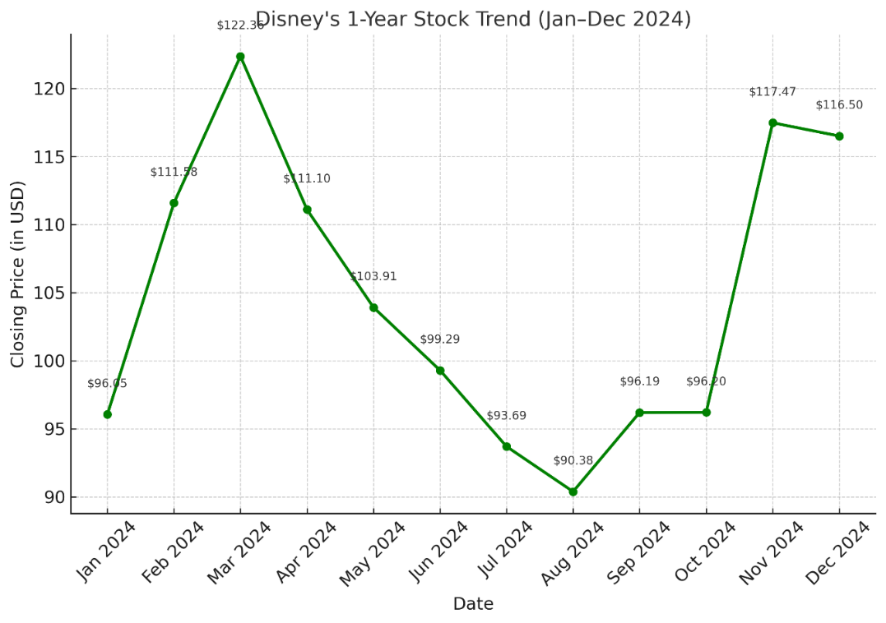

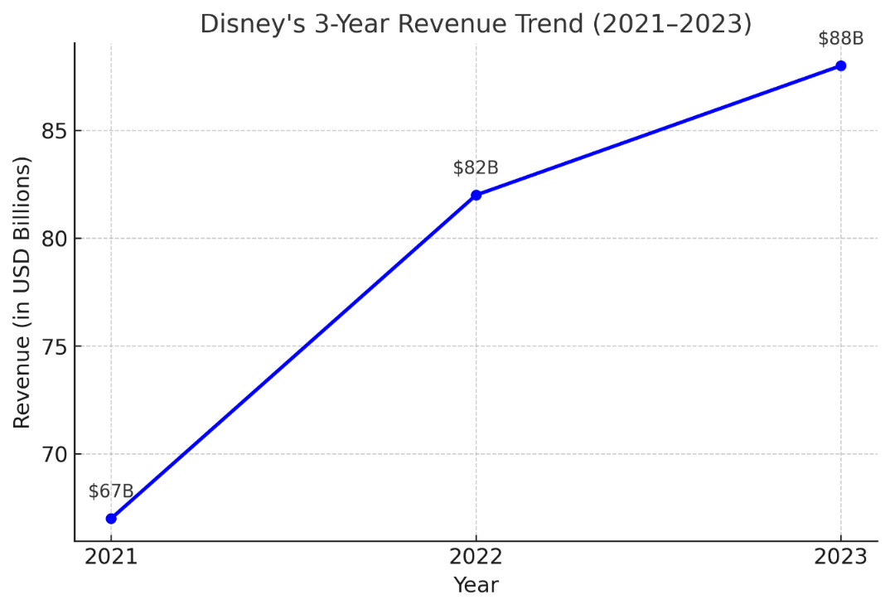

**Business Event #1: Financial Resilience and Shareholder Value**

Disney’s financial performance and strategic innovations in 2024 highlight its resilience and ability to adapt to a rapidly evolving entertainment landscape. The company declared a 33% dividend increase, bringing its cash dividend to $1 per share, paid in two installments of $0.50 each. This decision reflects Disney’s strong fiscal health and commitment to shareholder value following a year of significant revenue growth. For the fiscal year, Disney reported $91.4 billion in revenue, a 3% increase over 2023, with $22.6 billion generated in the fourth quarter alone (Manfredi). The company also achieved $321 million in streaming profit during Q4 and $134 million for the year, underscoring the strength of its direct-to-consumer offerings (Manfredi).

## **Business Event #2: Streaming Innovation and Growth Potential**

In tandem with its financial success, Disney continues to prioritize innovation within its streaming platforms to strengthen engagement and retention. As part of this effort, Disney integrated ESPN content into the Disney+ platform in December 2024, allowing bundle subscribers of Disney+, Hulu, and ESPN+ to access ESPN programming directly from the Disney+ app. This seamless experience is designed to reduce app friction and encourage upgrades to Disney’s full streaming bundle (Masunaga). For standalone Disney+ subscribers, a curated selection of ESPN+ and Hulu content, including live sports like NBA games and shows such as *Shogun* and *Will Trent*, is available, further enticing users to explore premium options (Masunaga). Looking ahead, Disney projects robust growth across its entertainment and sports segments. The company anticipates double-digit growth in entertainment operating income in fiscal 2025, fueled by theatrical releases, while sports income is expected to grow 13%, even with challenges posed by the business (Manfredi). Disney’s broader vision for its streaming services includes achieving a 10% operating margin by 2025, positioning it as a formidable competitor in the global streaming market (Masunaga). Through strategic innovations and fiscal discipline, Disney reinforces its status as a leader in the entertainment industry while navigating an increasingly competitive landscape.

### **Works Cited**

* Disney Corporate Social Responsibility Report 2023. The Walt Disney Company, 2023. PDF.
* *The Walt Disney Company*, 14 Nov. 2024, thewaltdisneycompany.com/#:~:text=The%20mission%20of%20The%20Walt,the%20world’s%20premier%20entertainment%20company.
* Rodriguez, Sara. “ESG Case Study – The Walt Disney Company.” *Sage Advisory*, 3 Dec. 2021, <https://sageadvisory.com>.
* Manfredi, Lucas. "Disney Declares Cash Dividend of $1 Per Share, a 33% Boost From Last Year." *Yahoo Finance*, 4 Dec. 2024.
* Masunaga, Samantha. "ESPN on Disney+ Launches Wednesday, as Disney Looks to Increase Streaming Subscribers." *Los Angeles Times*, 4 Dec. 2024.
* “The 2020 World’s Most Valuable Brands.” *Forbes*, Forbes Magazine, 2024, www.forbes.com/powerful-brands/list/.
* “Fortune 500.” *Fortune*, Fortune, 10 July 2024, fortune.com/ranking/fortune500/.
* “Fortune Global 500.” *Fortune*, Fortune, 4 Aug. 2024, fortune.com/ranking/global500/.
* “Fortune Sector Leaders: Media.” *Fortune*, Fortune, 16 July 2024, fortune.com/ranking/fortune500/sector/media/.
* “World’s Most Admired Companies.” *Fortune*, Fortune, 10 July 2024, fortune.com/ranking/worlds-most-admired-companies/.
* Satriana, Siti Shafira, and Tirta Nugraha Mursitama. “The Importance of Disney’s Supply Chain Investment Program in Overcoming the Dark World of Disney.” *E3S Web of Conferences*, vol. 388, 2023, pp. 1–9, <https://doi.org/10.1051/e3sconf/202338803019>.
* Statista. "Number of Employees of The Walt Disney Company Worldwide from 2006 to 2023." Statista, 2023, [www.statista.com/statistics/1449609/global-employee-numbers-waltdisney](https://www.statista.com/statistics/1449609/global-employee-numbers-walt-disney%20company/#:~:text=In%20the%20fiscal%20year%20ended,the%20remaining%20share%20working%20internationally.)company/#:~:text=In%20the%20fiscal%20year%20ended,the%20remaining%20share%20working%20internationally.
* Disney (DIS) Stock Price, News, Quote & History *Yahoo Finance,* [*https://finance.yahoo.com/quote/DIS/*](https://finance.yahoo.com/quote/DIS/)
* Netflix (NFLX) Stock Price, News, Quote & History *Yahoo Finance*, <https://finance.yahoo.com/quote/NFLX/>
* Whitten, Sarah. “3 Disney Films Could Top $1 Billion at Box Office This Year” *CNBC*, 8 Aug. 2024, <https://www.cnbc.com/2024/08/08/3-disney-films-could-top-1-billion-at-box-office-this-year.html>